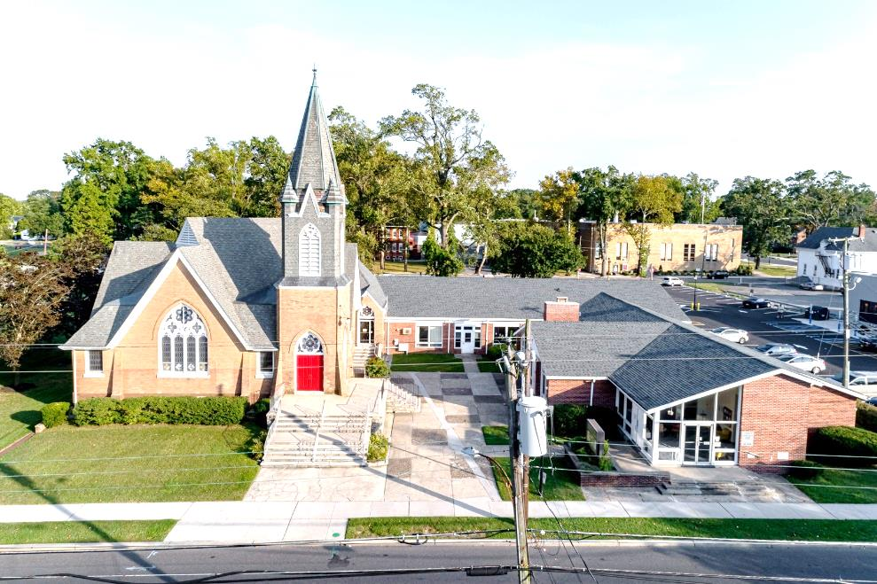

The Presbyterian Church at Hammonton
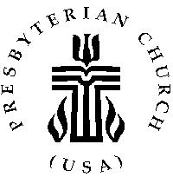

Our vision is to open our doors to all seeking a spiritual home of worship and to carry the light and love of Jesus Christ, our Savior, throughout the community.

MISSION STATEMENT
We are committed to Jesus Christ and the growing of his Church by glorifying God and by proclaiming the good news of the gospel through word and deed. We involve and reach out to our members and our community in Christ’s name through worship, Christian Education, and stewardship to support the mission of our church.

Note: Special thanks to Rev. Dr. Patricia Epprecht for leading us in worship today.

Organist: Cindy Birnbaum
Sunday School Superintendent: Beth Burkett-Rice

2022 2023 2024
ELDERS
Eric Copenhaver Dorrine Esposito Sallye Hershman
Marylee Kondrach Richard Walker Paul Moul
Charles Muller Johanna Johnson

DEACONS
Elsie Bakley Wendy Copenhaver Hilda Lugo
Nancy Foster Ann DiMeo Carol Orsi
Margaret Jones Rebecca Lindstrom Rebecca Villani

Clerk of Session: Beth Burkett-Rice

Church Office: 326 Bellevue Avenue, Hammonton, NJ
Office hours: Tuesday - Thursday 9:30 AM to 12:30 PM
Phone (609) 561-0168 ~ Fax (609) 561-6105
e-mail: office@hammontonpres.org
website: www.hammontonpres.org

THE CELEBRATION OF WORSHIP
JANUARY 22nd, 2023
3RD SUNDAY AFTER EPIPHANY
VIRTUAL & LIVE SERVICE
11:00am
****************************************************
~ GATHERING IN GOD’S NAME ~
“Welcome to the Presbyterian Church at Hammonton, we are glad you are able to join us. As we gather for worship feel free to pray and meditate on God’s calling in your life. Be respectful of others around you who might be doing the same, prior and during the Prelude, keeping your voice and conversation soft and to a minimum.”
Man may dismiss compassion from his heart, but God never will.
- William Cowper (1781-1800)

PRELUDE-“My Shepherd Will Supply My Need”- M. Limbaugh
“By Waters Still”(Psalm 23)- J. Rasley
“Praise, My Soul, the King of Heaven”– L. Smith

~ TIME FOR CENTERING STILLNESS AND SILENCE ~

WELCOME AND ANNOUNCEMENTS

THE PEACE
Let the people greet one another by staying in their seats and saying: “Peace be with you!”

INTROIT
~ HUMBLY APPROACHING GOD ~

OPENING PRAYER
Great God,
Your Son, our Savior, the Christ has brought us to a place of newness with you. Bring us to the place where we can begin to walk the paths by your side.
Lead us to the streams of life giving water. Fill us with your breath of life and make us new creations in you. Amen

CALL TO WORSHIP (Adapted Isaiah 49:1-7 & Psalm 40:1-11)
One: Listen to me, all of you. The Lord called us before we were born, while we were still in our mother’s womb. That’s when God named us.
All: God put a new song in my mouth, a song of praise to our God.
One: And God says to us, “You are my servants in whom I will be glorified.”
All: What great joy when we put our trust in the Lord, and do not put our faith in false gods.
One: Now the Lord, who formed us in the womb to be the Lord’s servant, reminds us that we are called to bring light to the nations.
All: Happy are we who put our trust in the Lord.
One: God says of us, “I will give you as a light to the nations so that my salvation may reach to the end of the earth.”
All: Let us worship the God of our creation, the God of our calling, the God who sends us out to preach the good news.

*HYMN #2022 ~ “Great is the Lord”

CALL TO CONFESSION

PRAYER OF CONFESSION (unison)
Gracious God, in your presence we learn to know you and we learn more about ourselves. You reach out in love and grace to us, yet we are reluctant to extend a hand to each other. You call us to give ourselves for the sake of the world, but instead, we struggle to keep our status in society. Forgive us and enable us to acknowledge that our gifts and resources come from you. Empower us to live and work as your servant people, through the grace of Jesus Christ and in the power of the Holy Spirit.
(Silent confession)
ASSURANCE OF FORGIVENESS

*GLORIA PATRI

ANTHEM~ “Amid the Cold of Winter”

CHILDREN’S MESSAGE

~ RECEIVING GOD’S WORD ~

PRAYER OF ILLUMINATION

SCRIPTURE READINGS Isaiah 40:18-24 (OT, p.634)
Ephesians 1:1-14 (NT, 180)
John 17:6-11, 20-21 (NT, 106)

MESSAGE ~ “Great Compassion”
- the Reverend Dr. Patricia Epprecht
Text: Holy Father, protect them in your name that you
have given me, so that they may be one, as we are
one. John 17:11b

~ RESPONDING TO THE WORD ~

*HYMN #2145 ~“God’s Great Loving Is So Amazing”

*APOSTLES’ CREED (page 14)

JOYS AND CONCERNS OF THE CHURCH

PASTORAL PRAYER & LORD’S PRAYER
Our Father, who art in heaven, hallowed be Thy name. Thy kingdom come, thy will be done, on earth as it is in heaven. Give us this day our daily bread; and forgive our debts as we forgive our debtors; and lead us not into temptation, but deliver us from evil. For Thine is the kingdom and the power and the glory, forever. Amen.
THE OFFERING OF OUR GIFTS AND OURSELVES

OFFERTORY-“For This We Pray” – T. Birchwood

*DOXOLOGY (#592)
Praise God, from whom all blessings flow; Praise Him, all creatures here below; Praise Him above, ye heavenly host; Praise Father, Son, and Holy Ghost. Amen.

OFFERTORY PRAYER

~ GOING IN GOD’S NAME ~

*HYMN #2158~ “Just a Closer Walk with Thee”

*THE CHARGE AND BENEDICTION

POSTLUDE~ “Go Therefore”-R. Smith

OUR WORSHIP HAS ENDED, LET OUR SERVICE BEGIN

*Signifies stand if comfortable.

~
Coffee Hour

Coffee hour is a time to grab a quick snack or relax and visit with old friends. It is also a time to make new friends. Churches gain strength when members share Christian Fellowship. Hope to see you in the lounge after the service.
~

Last Week’s Attendance & Offering:
Attendance: 51 people
Offering: $4,754.75

______________________________________________

CHURCH EVENTS

>>>THIS WEEK:

Monday-01/23:
9:00 AM Clothing Closet
-12:00 PM
7:30 PM ESL classes

Tuesday-01/24:
9:00 AM Clothing Closet
-12:00 PM

Wednesday-01/25:
9:00 AM Clothing Closet
-12:00 PM
7:30 PM ESL classes

______________________________________________

>>UPCOMING:

Monday-01/30:
9:00 AM Clothing Closet
-12:00 PM
7:30 PM ESL classes

Tuesday-01/31:
9:00 AM Clothing Closet
-12:00 PM

Wednesday-02/01:
9:00 AM Clothing Closet
-12:00 PM
7:30 PM ESL classes

______________________________________________

BIRTHDAYS:

January 26 Ed Clarke

______________________________________________

ANNIVERSARIES:

No anniversaries this week.

SERVING YOU TODAY:

Liturgist: Charles Muller

Ushers: Richard Walker, Captain
Richard Gibson
Ruth Gibson
Bob Rebek
Millie Walker

**Children’s Church: Donna Brown
Next week: Becky Villani

